60G Radar Module
MS60-1211S80M-Parking
Product manual

Document Revision History
Version | Revision Content | Revision time
V1.0 | Pre-release version | 2025.9.2

Product Catalogue

1 Product Overview 1
1.1 Product Introduction 1
1.2 Function Description 1
2 Technical Specifications 1
2.1 Radar Parameters 2
2.2 Electrical Characteristics 2
3 Module dimensions and pin descriptions 2
3.1 Size and Packaging 2
3.2 Pin Description 4
3.3 Output parameters 4
4 Typical Applications 5
4.1 Basic Functions 5
4.2 Application Expansion 5
4.3 Typical application circuit 6
4.4 Customization options 6
5 Installation Method 6
5.1 Horizontal installation 6
5.2 Inclined Installation 9
6 Important Notes 9

Product Overview

Product Introduction
MS60-1211S80M-Parking is a high-performance 60GHz millimeter-wave radar sensor module launched by Daicheng Technology. It is based on the 1T2R frequency-modulated continuous wave signal processing mechanism. By measuring the centimeter-level distance of targets within the detection range and perception, it can achieve the function of reversing distance measurement radar.

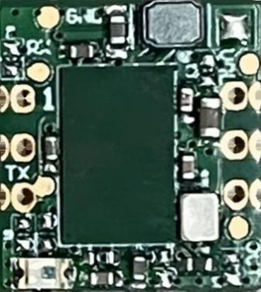
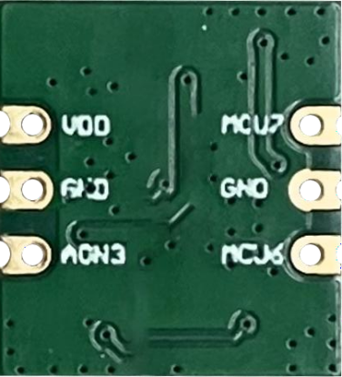

Figure 1-MS60-1211S80M-Parking

Function Description

Reverse vehicle target positioning:
This radar module can output real-time position information of the closest target within the detection range, including distance and angle.

Technical Specifications

Radar Parameters

Parameters | Numerical value | Unit
Working frequency | 59~64 | GHz
Bandwidth | 5（Adjustable） | GHz
Modulated waveform | FMCW | /

Transmission power | 11 | dBm
Horizontal | ±60 | °
Vertical | ±60 | °
Detection Range | ≤3 | m

Electrical Characteristics

Parameters | Numerical value | Unit
Working voltage | 3.0~5.5 | V
Average working current | 80（Adjustable） | mA
Operating temperature | -30~85 | ℃
Storage temperature | -40~125 | ℃
Communication interface | GPIO， UART | /

Module dimensions and pin descriptions

Size and Packaging
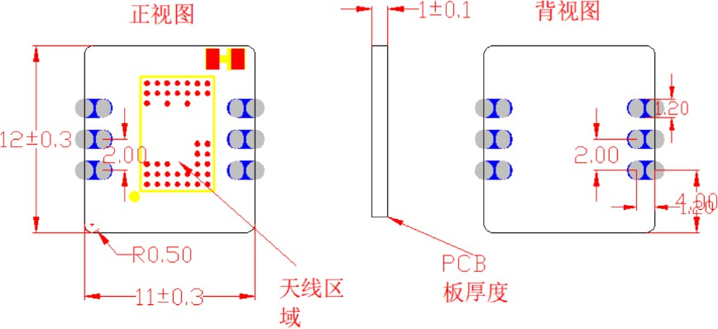
Figure 2 -Schematic diagram of radar module structure
    - Volume (L*W*H, mm): 12.0 * 11.0 * 2.0
    - Interface: Dual row 1*3 straight insertion / stamp hole interface

Pin Description

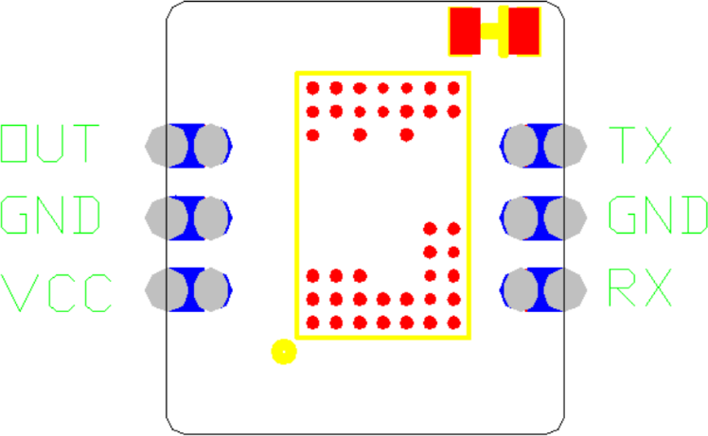
Figure 3- Pin Definitions for Radar Module

Interface | Pin | Name | Type | Explanation
Interface 1 | 1 | OUT | GPIO | Signal output
 | 2 | GND | GND | Power ground
 | 3 | VCC | PWR | Power supply
Interface 2 | 1 | TX | UART | Serial port output
 | 2 | GND | GND | Power ground
 | 3 | RX | UART | Serial port input

Output parameters
    - Target information: Distance, Angle
    - Product Information

Typical Applications

Basic Functions

Support target positioning
The multi-channel millimeter-wave radar has a relatively good angle measurement capability. This radar module uses two antennas to receive signals and measure the phase difference of the signals' arrival times. Through phase comparison, angle estimation (DOA) is achieved. This technology can accurately measure the horizontal angle of the target object relative to the radar. Combined with the high-precision ranging capability, it enables the positioning of the target in a two-dimensional space.

Application Expansion
This radar module can be installed independently at the rear of the vehicle for use in reversing scenarios. It can provide real-time position information of the nearest obstacle detected by the radar, including distance and angle. It can also be linked with the reversing camera to offer the owner stable detection of reversing scenarios.


















Figure 4 -Example of the application of this radar module in the reversing scenario

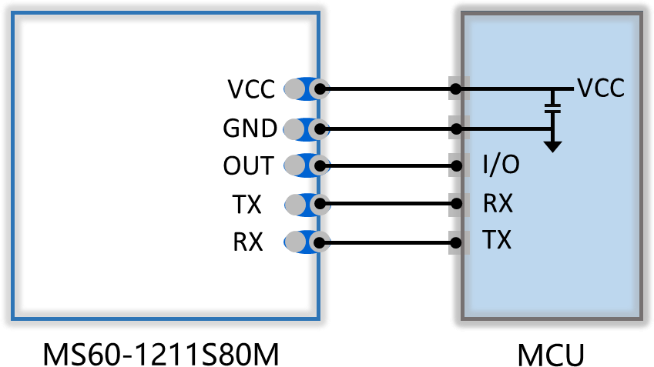
Typical application circuit

Figure 5- Schematic Diagram of the Connection of Peripheral Devices for This Radar Module

Customization options
Power supply voltage | Inductive output mode | Adjustment method | Cheating function
☑3.3V | ☑ IO Output | □ IO Adjust parameters | □Photosensitive
☑ 5V | ☑ UART | ☑ UART | □ Power management
□12V | □ PWM | □ IIC | ——
□ 24V | —— | —— | ——
Note：□ Supportable ☑ Supported

Installation Method
This radar module is only compatible with horizontal installation and inclined installation.

Horizontal installation
When installed horizontally, the radar module is attached to the rear of the vehicle, with its viewing angle facing horizontally towards the monitoring area. This is suitable for vehicles with a relatively low chassis such as compact cars.
In this installation mode, the maximum detection distance for targets is 3 meters, and the near-range blind area is 0.15 meters.

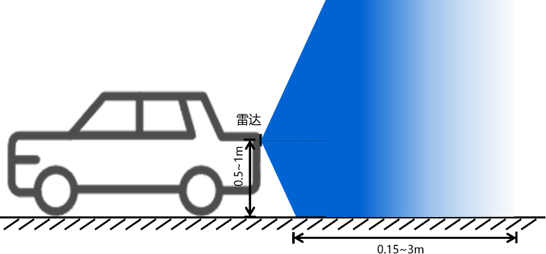
Figure 6 -Schematic diagram of the flat packaging of this radar module

Suggested installation location：
- Installation height：0.5~1.0m
- Detection range：≤3m
- Detection blind zone：0.15m

Inclined Installation
When installed at an angle, the radar module needs to be given a certain inclination angle. This is mainly applicable for monitoring from a higher position downward or from a distance. It is generally suitable for vehicles with a relatively high chassis, such as trucks, to conduct detection and monitoring from top to bottom within the space. The detection area will be affected by installation factors such as height and inclination angle, resulting in different area ranges.
In this installation mode, the maximum detection distance of the target is 2.5m, and the near blind zone is 0.15m.

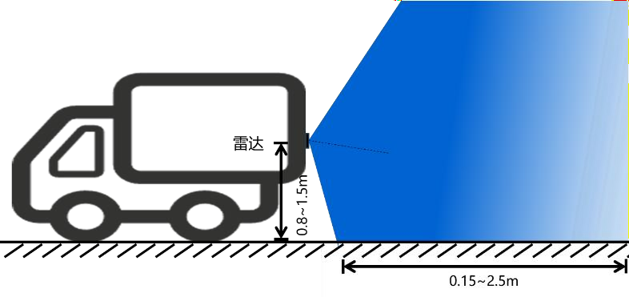
Suggested installation location:
    - Installation height：0.8~1.5m
    - Inclination angle：15°~30°
    - Detection range：≤2.5m
    - Detection blind zone：0.15m
Figure 7 -Schematic diagram of the inclined installation of this radar module

Important Notes
- During the installation and operation of the radar module, the inner and outer surfaces of the secondary cover should be smooth and flat, with uniform thickness. For flat or spherical surfaces, they should not be uneven; if there is a surface coating, it should not contain any metal or conductive materials.
- Within the radar FOV coverage area, there needs to be a good clear space in the antenna radiation area to avoid any metal. The material casing or support components should be used to prevent interference.
- Try to avoid pointing the radar module antenna directly at large metal equipment or pipes, etc., to avoid false alarms.
- Due to the radiation characteristics of the radar antenna, the radar detection range is distributed in a water-drop shape starting from the radar antenna surface. Deviating from the normal direction of the radar center line, the effective range will be reduced.
- The physical system of millimeter waves affects the radar module's operating range, which is related to the target's reflection intensity, the material and thickness of the target's covering, etc. The effective range of the radar will fluctuate to some extent. For the detection of living targets, different body positions and states will affect the radar's operating range. The radar does not guarantee that it can reach the maximum operating range in all states.
- When multiple radar modules are installed, it is best to avoid mutual irradiation between the antennas of each module and keep a distance of more than 1m between the modules.

